Task 5 Report — Solar Flare Intensity Mapping (Activities 1 & 5)
Course: COSC 3337 – Data Science
Student: Maryam Jamlaney
Date: ________11/08/2025______

C. Methodology
This project combined Activities 1 and 5 to analyze solar flare intensity patterns across Solar Cycle 24 using the RHESSI Solar Flares dataset (2025 version).
The dataset included the following attributes: date, x_pos, y_pos, duration, total_counts, and energy_band.
Pre-processing involved converting all numeric fields, removing missing values, and excluding the 3–6 keV energy band per assignment guidelines.

Method 1 – Counts Intensity
Flare intensity was defined as the total photon counts per event.
A two-dimensional grid over (X_pos, Y_pos) was created, and total photon counts were summed inside each cell.
The resulting heatmap visualized regions on the solar disk with the highest emission activity, regardless of duration or energy range.

Method 2 – Duration × Energy Band Weight
In this approach, both flare duration and energy were considered to yield a more physical measure of intensity.
Each energy_band label (e.g., 6–12, 12–25) was parsed to extract its numeric range, and the midpoint was computed as (low + high)/2 keV.
Any upper bound above 800 keV was capped to prevent skewing, and the 3–6 keV band was excluded.
Each flare’s intensity = duration × energy midpoint weight.

Visualization Process
Both methods were visualized in R using packages ggplot2, dplyr, readr, stringr, and scales.
Heatmaps were produced with a grid resolution of 150 bins per axis, allowing for a consistent spatial comparison between methods.
These visualizations highlighted differences in flare activity based on how intensity was defined.

D. Results and Analysis
Numerical Results
- Total Intensity (Method 1: total_counts): 132,886,187,415
- Total Intensity (Method 2: duration × energy_band): 558,491,752

Spatial Findings
- Method 1: Strong photon-count clusters were observed near the center and right edge of the solar disk, representing regions of intense photon emission regardless of duration or energy.
- Method 2: Hotspots shifted toward zones dominated by high-energy and long-duration flares, showing different spatial patterns and reduced overall intensity.

Comparison Between Methods
Method 1 captures raw emission volume and highlights areas with the largest photon output.
Method 2 weights events by both duration and energy, emphasizing sustained or energetic flares over short, bright bursts.
Because Method 2 scales by duration × energy rather than raw counts, its total intensity is much lower.
Together, these maps offer complementary insights into flare distribution and energy significance.

Visualizations
Figure 1 — Flare Intensity Based on Total Counts (Method 1)
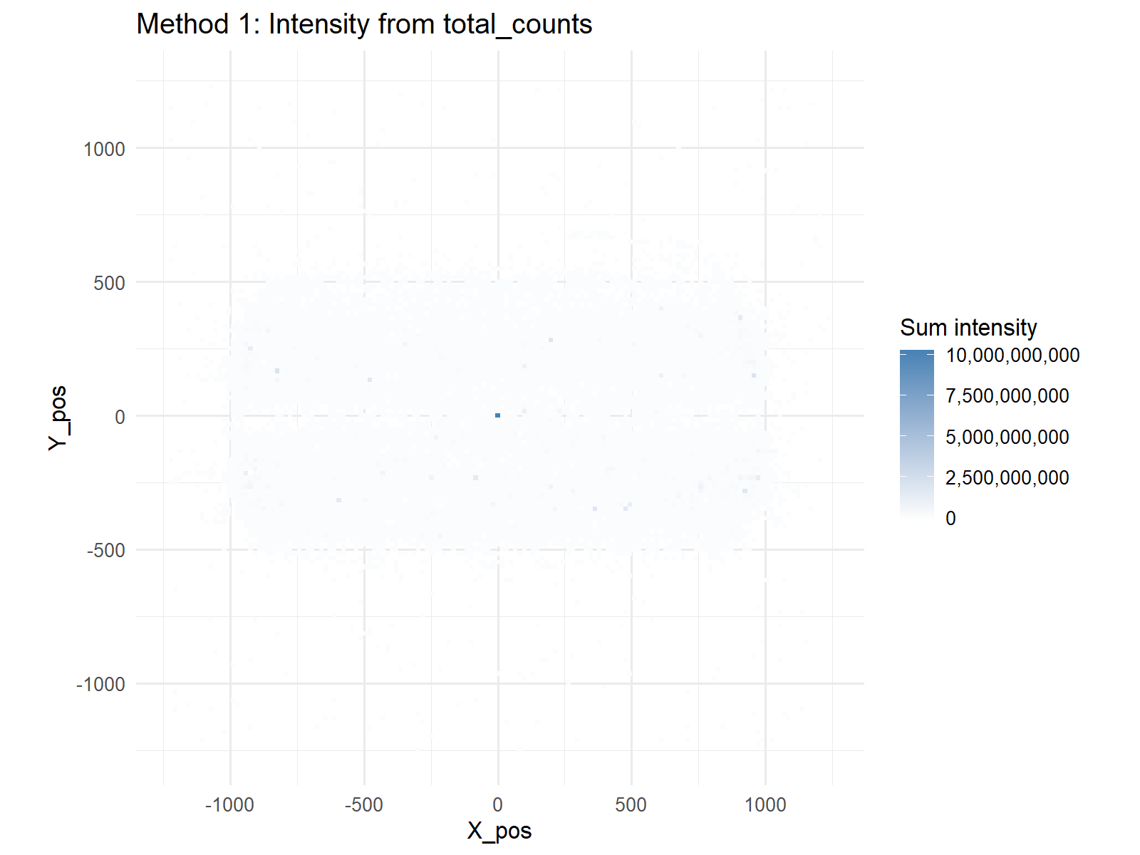
Figure 2 — Flare Intensity Based on Duration × Energy Midpoint (Method 2)
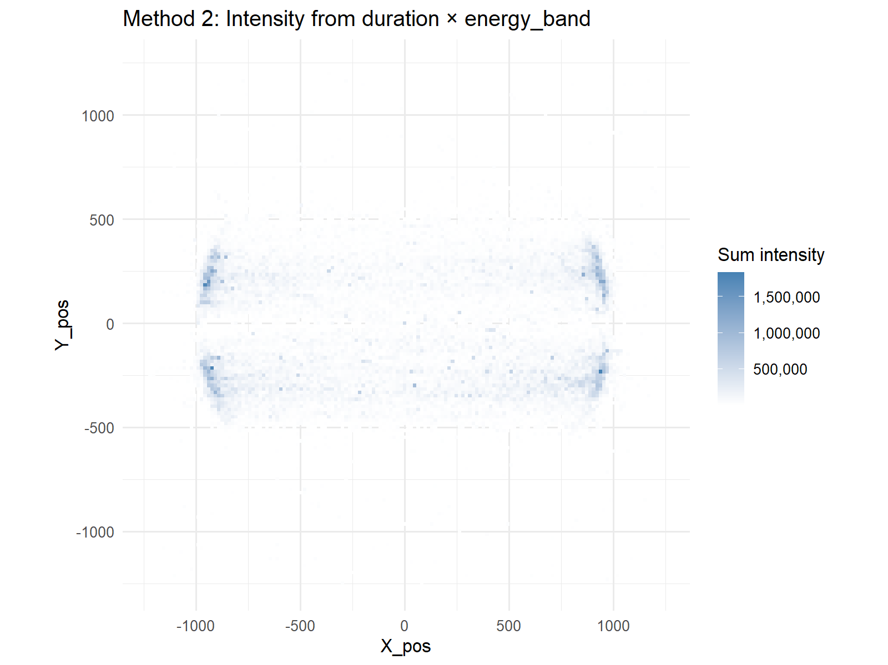
These heatmaps demonstrate how solar flare hotspots shift depending on the chosen intensity definition.
While Method 1 highlights photon volume, Method 2 emphasizes sustained high-energy flare activity.

E. Discussion and Conclusion
The analysis showed that solar flare activity varies greatly depending on the definition of intensity.
Method 1 identifies regions of high photon output but can over-represent short bursts.
Method 2 captures energetically significant or long-lasting flares, providing a more refined view of solar energetics.
The difference in total values (≈132 billion vs ≈558 million) highlights the impact of energy-based weighting.
Overall, this comparative approach deepens understanding of solar flare patterns and their relation to the solar cycle.
Future work could integrate temporal or sunspot correlation analysis to investigate how flare energy evolves over time.

